2018 Cheyenne Farmers Market is SPONSORED BY:

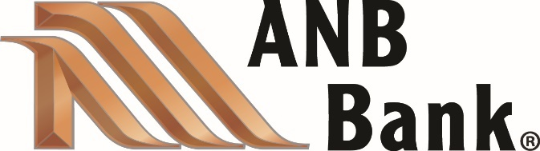

- #1 PROPERTIES Deborah Wall
- Datacorp
- Halladay Subaru
- Quick Services LLC

