2018 Cheyenne Farmers Market is SPONSORED BY:

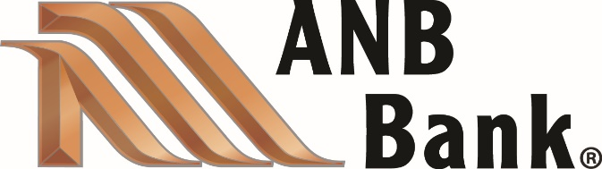

AND:
#1 PROPERTIES Deborah Wall
Datacorp
Halladay Subaru
Quick Services LLC

